Professional Advice
A Will is a legal document, so it is essential to have it drafted by a solicitor. This will ensure you have peace of mind knowing your Will reflects your wishes. The Law Society of Scotland can help you find a solicitor. There are also a few free, low-cost or charity schemes available, including:
Free Wills Month : those 55 and over can have a will written with selected solicitors for free in March and October each year. (There is no obligation to donate to one of the supporting charities, but you may wish to do so).
Will Aid : similarly, instead of charging their normal fees, solicitors who partner with the Will Aid scheme will invite you to make an upfront donation to Will Aid. Donations raised through the campaign support the work of eight partner charities.
If you already have a Will, it is important to keep it up to date. You can add to it or change its provisions at any time with a written instruction called a codicil. Again, you should seek the assistance of a solicitor.
Types of Legacies
Pecuniary legacy - a gift of a fixed sum of money. Bear in mind that inflation will affect the value of your gift.

Specific Legacy – a gift of a particular item, e.g. land, property, stocks and shares, the proceeds of a life insurance policy, jewellery, or other assets.
Residuary Legacy – a gift of what is left of your estate (or a part of it) after all other bequests, debts, expenses and taxes have been paid. This type of legacy does not decrease in value due to inflation, so can be more beneficial to charities.
Suggested Wording
Your solicitor may find the following wording helpful when including the Free Church of Scotland in your Will:
“I give to Anytown Free Church of Scotland, Scottish Charity No SCXXXXXX, ….*[insert nature of legacy]…., free of all taxes for its general charitable purposes and I declare that the receipt of the Treasurer or other proper officer of Anytown Free Church, for the time being shall be a full and sufficient discharge for my executors.”
*(Insert one of these above)
1. The sum of £x [insert amount in words]
2. [insert %] of the residue of my estate
3. [insert specific item]



A Lasting Legacy:
Impact the
FUTURE

Leave a gift to support the ongoing mission of
Anytown Free Church

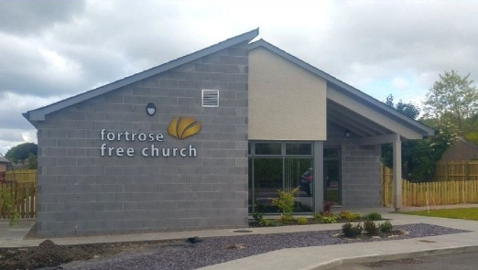

anytownfreechurch.org

Legacies are more than a financial gift. They tell a story of the people and causes we have most valued in life, testifying to our love, faith, values, priorities, and passions. After ensuring those closest to us are provided for, they can be gifts that speak of our desire to see the charities we have supported in life continue their work beyond our lifetime.
By choosing to leave a gift to Anytown Free Church, we can continue to support the mission of the church, bless others, see others impacted by the Lord Jesus as He has impacted and transformed our own lives, and further the work of the Gospel long after we are gone, impacting future generations.

Gifts made in a Will to a charity benefit from being exempt from Inheritance Tax; this means they are deducted from the value of the estate before Inheritance Tax is calculated, reducing the burden of this on loved ones. If a 10% or more of an estate is left to charity, Inheritance Tax may also be reduced on the rest of the estate.

Leaving a Legacy to Anytown Free Church
Legacies given to the congregation are used to sustain existing ministries and bring fresh possibilities for outreach, discipleship, fellowship and development well into the future. They can be left towards a specific area of ministry or life of the congregation such as youth work, or building fabric repairs and maintenance [add other suggestions for local situation], but it is more helpful and flexible if they are left for general congregational use since the church leaders can then decide at the time what is the greatest need.

Leaving a Legacy to the Free Church of Scotland
Our vision as a denomination is of “A Healthy Gospel Church for Every Community in Scotland”.
Legacies given to the Free Church of Scotland denomination will be used to support Church Development, Church Planting, Global Mission, Training Ministers, Supporting Church Leaders and Edinburgh Theological Seminary.
The Free Church of Scotland’s charity number is SC012925.

How to Leave a Gift in Your Will?
We may know it is a good idea to have a Will in place, but many of us put off writing one or never get round to doing it. Making a Will and keeping it up to date is the only way of ensuring your wishes are fulfilled after your death, giving you peace of mind that your loved ones are provided for and the causes you love are supported. Not having a Will in place can create unnecessary complications for your loved ones at an already difficult time.

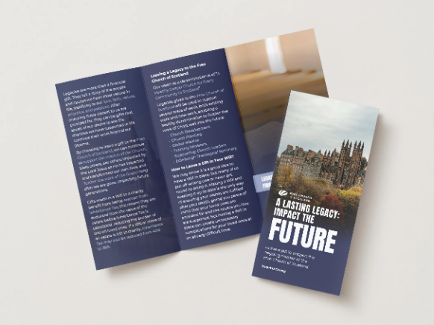

For further information on legacy giving, please contact the Treasurer: treasurer@anytownfreechurch.org

Anytown Free Church
Scottish Charity No SCXXXXXX

